Edward Cohen, a long-time state official who helped modernize New Jersey’s system of education in the course of three major initiatives that he led across the terms of four governors, died of natural causes on Feb. 2nd at age 89 while at his winter residence in Naples, Florida, according to friends and family.

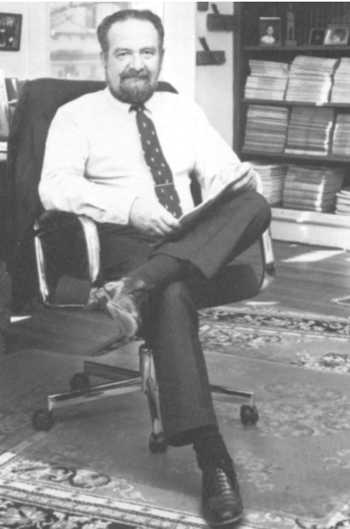

In the late 1980s, Cohen served as founding executive director of the New Jersey Commission on Science and Technology, an agency spun out of the higher education department under the first term of former Gov. Thomas Kean, with support from the state’s key business leaders. Earlier in his career, Cohen served as the state’s assistant chancellor of higher education, with responsibility for forming then-new system of county community colleges and also what became a statewide health sciences university.

Photo credit: Keith Dillon

The science and technology commission ultimately made nearly $100 million in capital grants to build and equip new “advanced technology centers” at the state’s major public and private research universities, as approved by voters in referenda appearing on the ballot in 1984 and 1988. At its peak, the science agency also made annual operating grants totaling $19 million to encourage research and commercialization of new technology.

“Ed was one of the first to understand that we could revitalize New Jersey’s economy by encouraging business/higher-ed partnerships and technology-based entrepreneurship,” said former Gov. Kean. “He convinced me we needed to build new facilities and start new programs to encourage that kind of work."

As Cohen once explained to The New York Times, “In the early 1980's, it was recognized that the era of the traditional smokestack industry was drawing to a close and that New Jersey's long-term economic future depended on creating and expanding advanced technological industries. Despite the state's existing strengths in various technological fields, it was apparent that a new strategy was necessary, one that would fuse the previously disparate objectives of economic development and support of higher education."

Former Gov. Kean recalled: “Ed helped convince me to appoint a blue-ribbon commission, whose recommendations charted a course followed by me and by several succeeding governors. Thanks in large part to him, we led other states in developing this new policy.”

Along with neighboring northeastern and also midwestern industrial states, New Jersey was among the first to deploy such programs. After a period of dormancy under the last several governors, the agency was revitalized in the current administration of Gov. Phil Murphy as the New Jersey Commission on Science, Innovation and Technology.

Cohen was born in the Bronx on Jan. 21, 1930. He went to Stuyvesant High School and the City College of New York, graduating cum laude in 1951. He also studied toward a master’s degree in political science at Columbia University, focusing on the Marxist theorist Eduard Bernstein.

After serving in the Korean War, Cohen joined the U.S. Foreign Service. Stationed in Belgrade as cultural attaché in the U.S. embassy to the former Yugoslavia, he edited a monthly magazine of democratic ideas written in Serbo-Croatian. Subsequently he served as educational affairs director with the U.S. embassy in Caracas, Venezuela, and with the International Development Foundation, a New York City-based nonprofit that assisted South American countries with economic growth, education and training.

During his Latin American travels, Cohen had met Ralph Dungan, a former White House advisor to President Kennedy who was then serving as President Johnson’s ambassador to Chile. Dungan left Washington after press disclosures that the National Student Association, of which Dungan had been an early leader, had been in part CIA-funded. Dungan was appointed by Gov. Richard Hughes in 1967 as the state’s first chancellor of higher education, and Dungan in turn recruited Cohen as assistant chancellor in 1969.

Cohen’s consequential assignments in higher-education reform included coordinating the establishment of the state’s system of county community colleges, authorized under the 1967 Higher Education Act, and creation of the College (later University) of Medicine and Dentistry of New Jersey, assembled in 1970 from several medical, dental, nursing, and allied-health schools under diverse ownership of Rutgers and Seton Hall Universities (now mostly returned to Rutgers) as well as a hospital-based osteopathic college of medicine in southern New Jersey now operated by Rowan University.

During non-winter months, Cohen lived in his meticulously restored home in Lambertville. In 1999 he authored and self-published a history of the town, “Lambertville’s Legacy.” Lambertville has been called the “Georgetown on the Delaware” since it has frequently hosted current and retired state government executives.

Cohen is survived by his second wife, the former Patricia Firth, and their stepchildren.